

September 5, 2023

Dear Friend,

On behalf of the Board of Directors, it’s with mixed emotions that we announce the departure of our long-time leader, Jo-Ann Schofield. Jo-Ann has been on staff for 26 years with 10 years as President & CEO and has made the decision to move on. Her last day on staff will be Friday, September 22.

We are grateful for all that Jo-Ann has done to build and strengthen the organization over the years and wish her well in her future endeavors.

The Board of Directors has named long-time employee and current Chief of Operations, Marc Mainville, as the Interim President & CEO. Marc has been on staff for over 15 years and has the skills, experience, enthusiasm for our mission, and historical knowledge necessary to guide the organization during the transition as we open the search for our next President & CEO.

We are excited for this new chapter of MENTOR RI as we continue to build on the strong foundation and long legacy of success that has been established by  
Jo-Ann and our incredible team.

Jo-Ann will be guiding the acquisition of MENTOR RI’s new home as our current lease with HarborOne expires in November. Stay tuned for that announcement and look for our Open House coming soon.

Our gratitude goes out to Jo-Ann for the decades of commitment she has poured into ensuring MENTOR RI reaches as many kids in need of mentorship as possible. Our organization is a better place because of her love for it!

I’d also like to thank Marc for his willingness to step up and guide us through this leadership transition.

Sincerely,

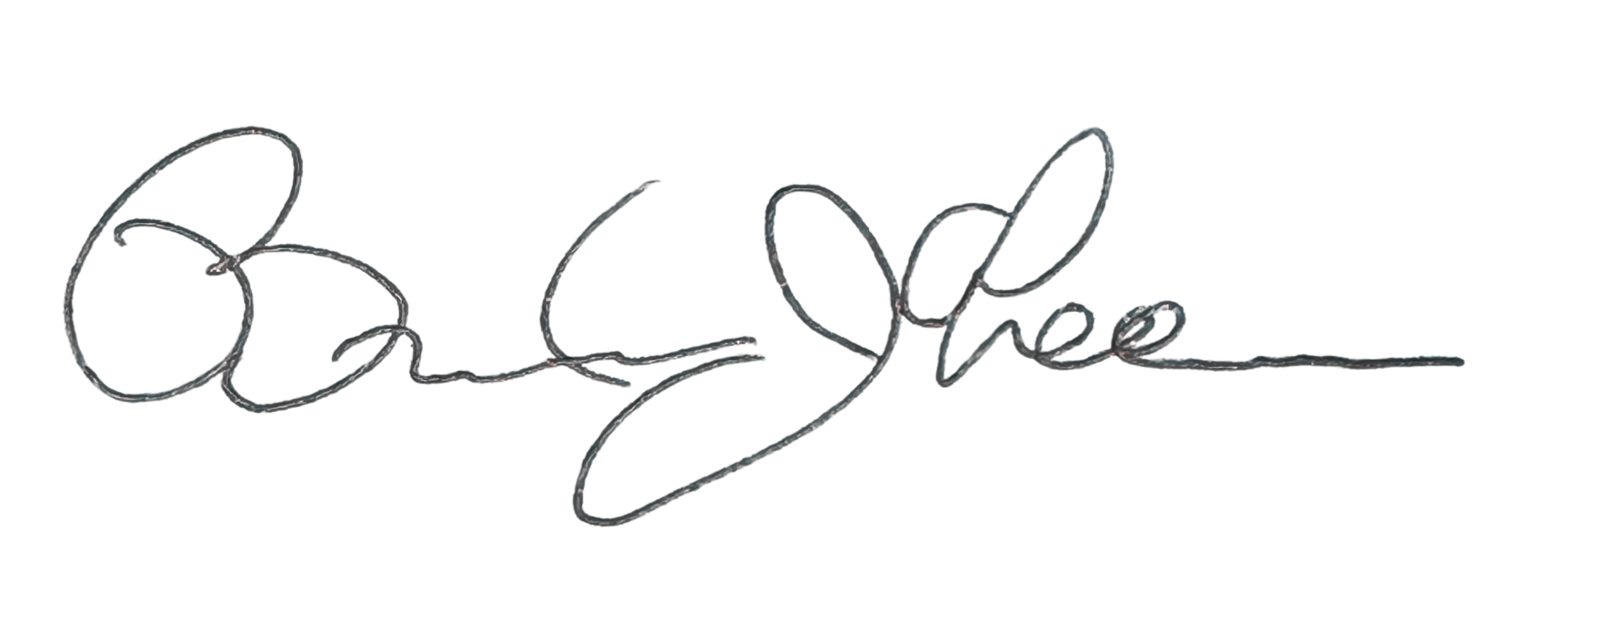

Brendan Ahearn  
Board Chair

***President & CEO***

Jo-Ann L. Schofield

***Board of Directors***

Brendan J. Ahearn

Autodesk

CHAIR

Jannel Hill

*Tufts University*

###### VICE CHAIR

Kyle Peterson

*Monomoy Advisors*

TREASURER

Lindsay N. Hamilton, Esq.

*FM Global*

SECRETARY

Rhonda Duckworth

The Washington Trust Company

Melissa Labrecque

*Amica Insurance*

Christina Markrush

*Mentor/Former Mentee*

Jocelyn Murta

EY

Monika Soban

*Amgen*

MENTOR Rhode Island:

The RI Mentoring Partnership is a 501(c)(3) Corporation

United Way   
Participant Agency